Team Portal

- Login or Register on http://www.Xtremeswim.com by clicking Login or Register at the top right of the page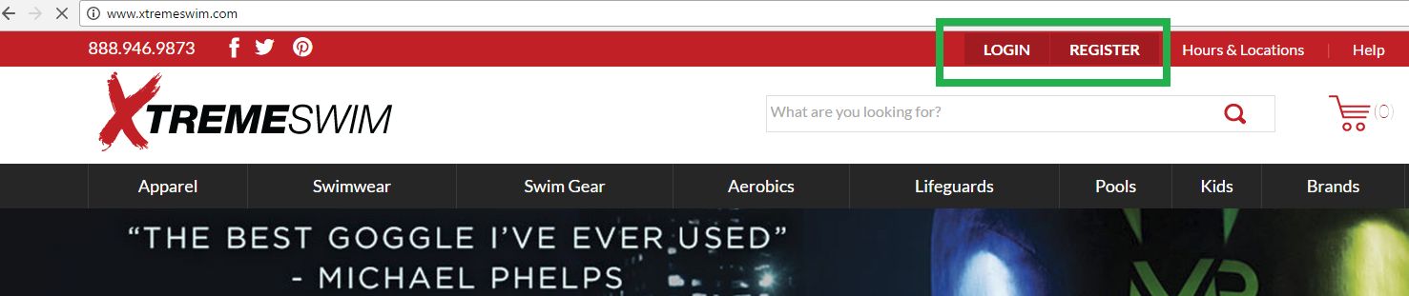
- If you have not registered, you need to register first. Then it will ask you for your code. 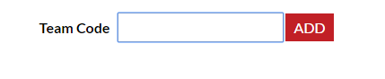
AESC
  - If you have already registered but forgot to add your team code – while logged in click on choose "Select Teams" at the top of the page, then "My Teams" and there will be a button that says "Add More Teams", and it will ask for the code.
- Then you should be able to choose “Select Teams” from the top and click on your team name. Your team portal with the team items and discounts will show up. You may leave your Team Portal to purchase other items, and return to Team Portal. **Please note that you must check out while still in the team portal in order for the discounts to show up. If you click on a different department, then you will no longer be in the team portal and the discounts will not show up and will NOT be applied at checkout**
  - If you purchase an item in your team store and hit continue shopping, make sure you hit your team code that is Red at the top left of screen below the black Navigation bar to stay in Team Store.
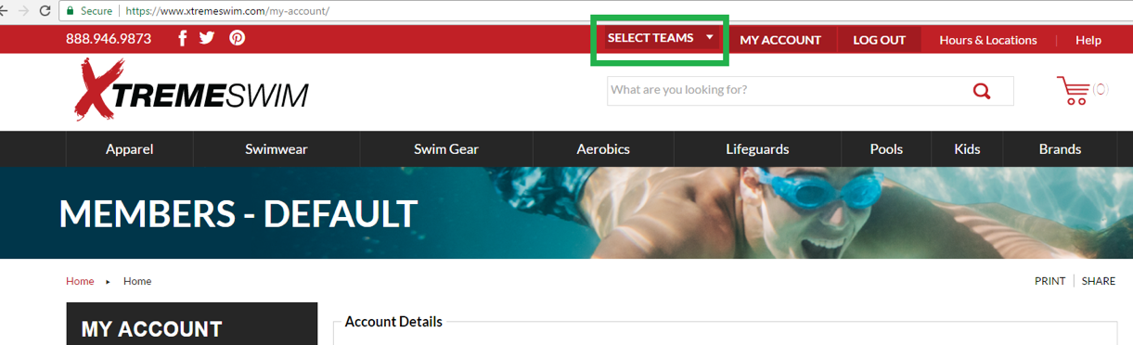
- If you have any issues, feel free to give us a call at (972) 596-2188 and we’d be happy to help walk you through it!
P.S. Orders over $65 receive free shipping with the code “FREESHIP” at check out!

5. On your Mobile Phone. Click Shop to the right of the search bar and log in.

